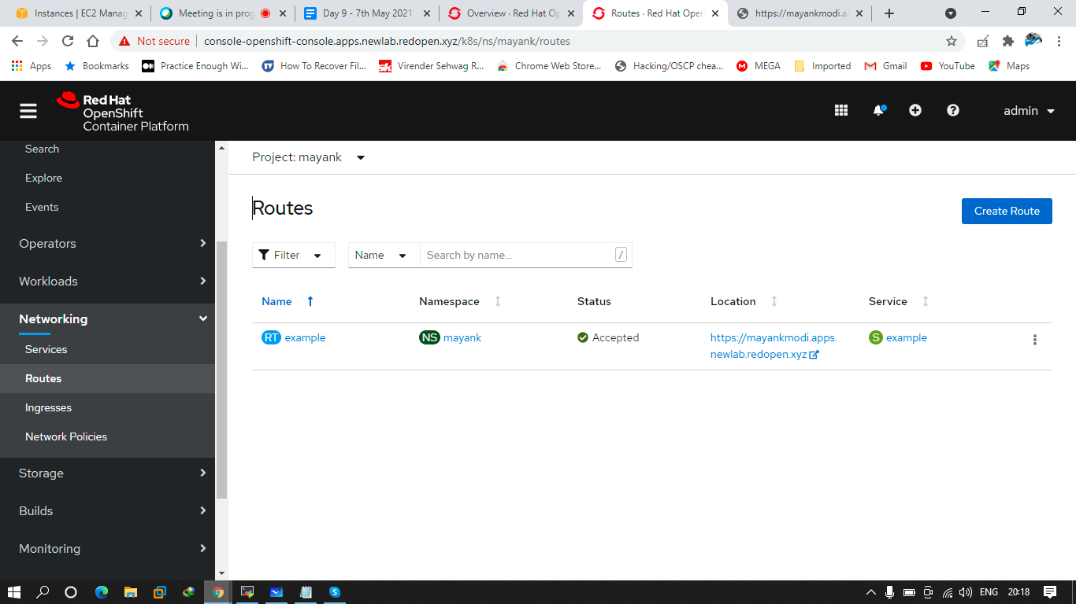

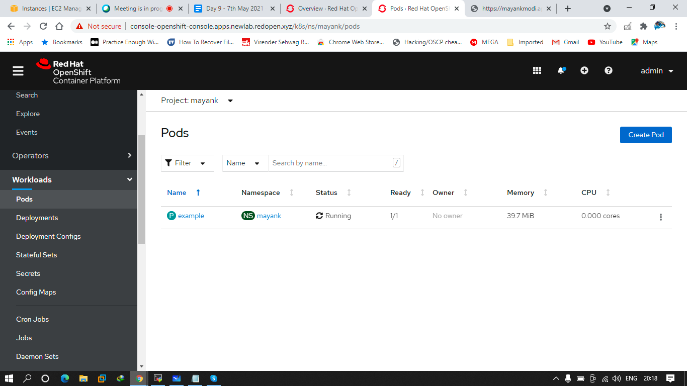

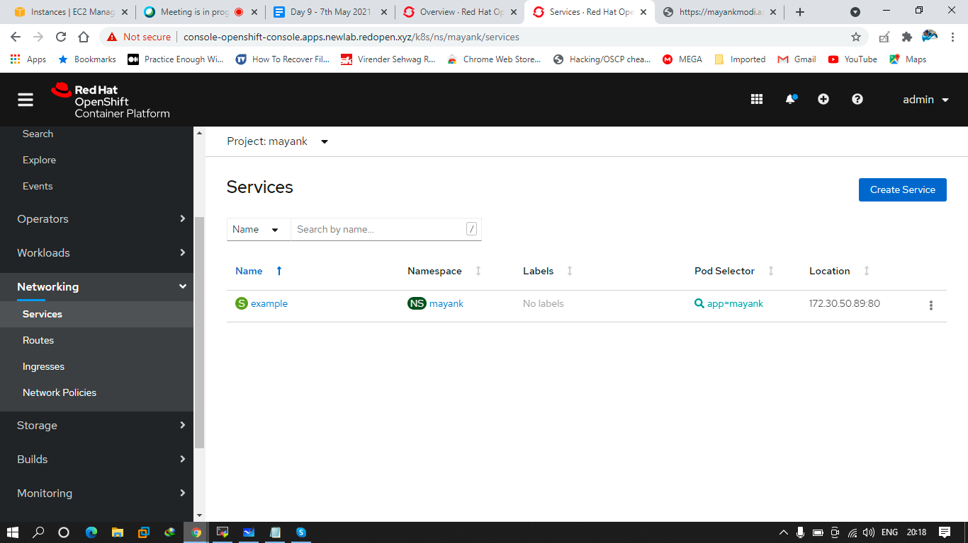

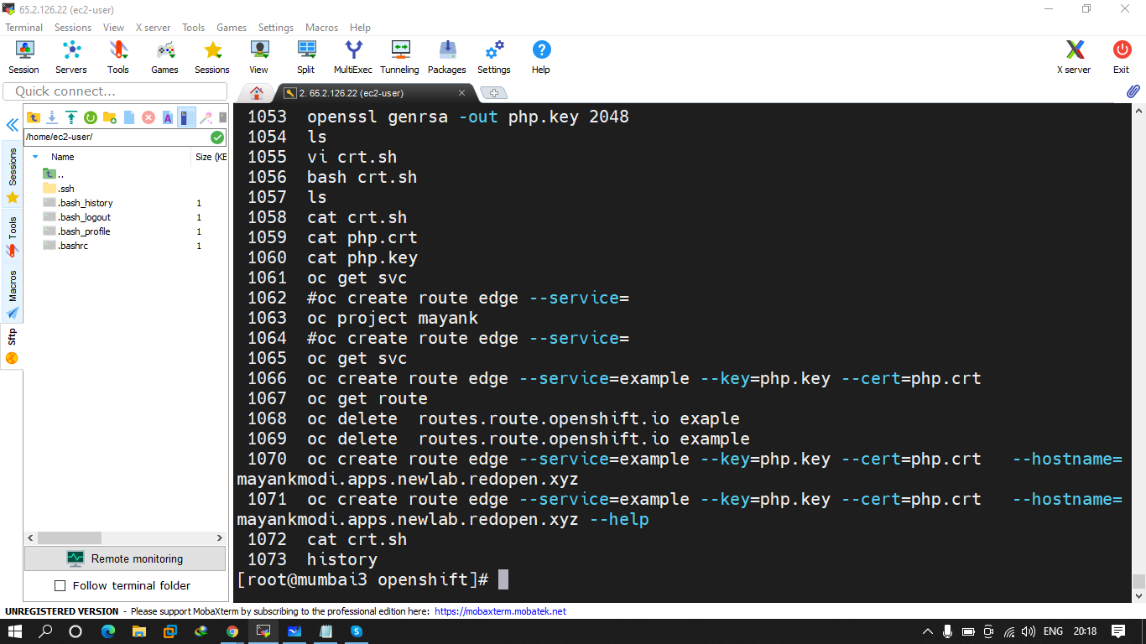

Q.1 create a pod using console using quay.io/mayank123modi/mynginx image and expose this into a secure route. And the content should be HELLO FROM MAYANK OPENSHIFT TRAINING